Abstract: Launching the ASF's Website
Mike Lake and Jill Rowling

The ASF has a Web presence all its own now, at http://www.caves.org.au
This is in keeping with the domain names chosen by the National Speleological
Society of USA (NSS) at http://www.caves.org and the British Cave Research Association (BCRA) at
http://www.caves.org.uk

The Web pages have been developed by Carol Layton, who is also responsible for the
Sydney Univerity Speleological Society's Web pages.

The ASF site is hosted at YourWeb (http://www.yourweb.com.au), a Sydney company, at reasonable commercial rates.
The company was chosen out of several contenders, and the decision was based on cost, services offered, ability to do the job, speed of delivery of Web pages and reliability as well as data backup and security.

It was intended to make this a joyous occasion so we chose to make the formal announcement on New Year's Eve at the party.

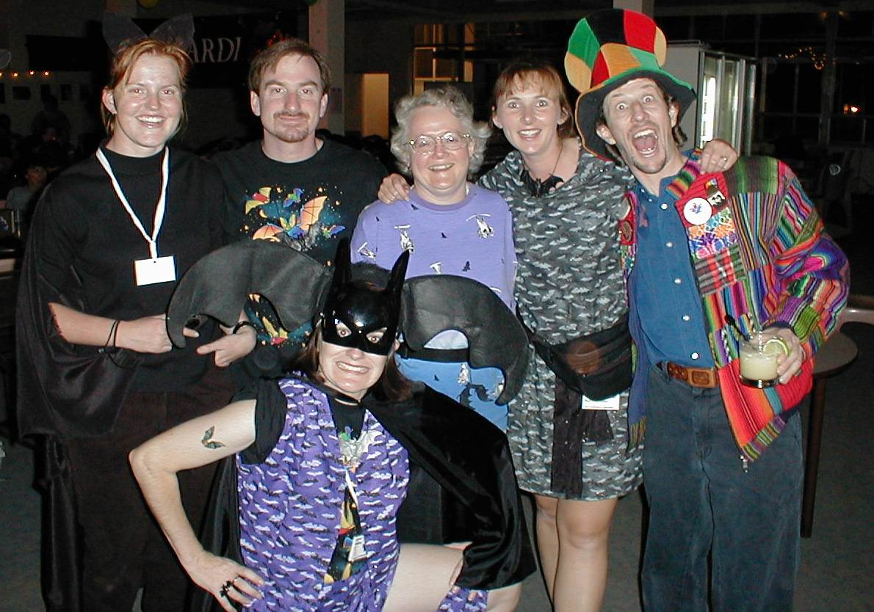
New Year’s Eve Bat Party revellers Arthur Clarke

The ASF's Web-based
National Karst Index Database
Implementation & Implications
Michael Lake
ASF Conference, Bathurst
January 2000

Abstract
The ASF's Web-based National Karst Index Database
Mike Lake and Jill Rowling

In 1985 the ASF produced a landmark document; the Australian Karst Index 1985 [1]. The 480 pages and coverage of around 6,500 caves in all states of Australia ranks this as an important reference work and an exemplary piece of work by the members of the ASF.
Since then, the Karst Index Database (hereafter referred to as KID) has been developed using the DOS-based Paradox database. Although it was basically functional, time has overtaken it in that few people are prepared to use the DOS-based system. Additionally setup can be tricky for users with newer MS Windows systems, the database can only be run by users with systems that support or emulate MS-DOS and users must obtain and install the software to run it.
Towards the end of 1999 Mike Lake and Jill Rowling put forward a proposal to the ASF to put the Karst Index Database on the Web, based on Open Source software. The general concept was accepted at the January ASF council meeting, and specifications refined over the year. In Spring 2000, tenders were drafted and circulated amongst the ASF Executive, the final request for tender was advertised nationally and a programmer was selected from many tenderers. A working system was developed within 2 weeks. The Web-based Karst Index Database was running on the ASF's Web site by December and ready for ASF's January Conference.
You can find the KID at ASF's Web site http://www.caves.org.au.
This paper covers:
- A brief history of the web-based KID and it's development
- Advantages of a Web-based KID
- Privacy and Security aspects
- Implementation and use of open source software
- Implications of open sourcing the KID software
- Where do we go from here?
A separate workshop was held at the conference to demonstrate the Web-based KID, how it can be used and to gauge feedback from cavers and speleologists.

1 History & Project Planning
A proposal to the ASF Executive in October 1999, by Michael Lake and Jill Rowling, ``Suggestions and Comments on the Karst Index Database'' [5] suggested:
``...the Karst Index Database should be implemented as a Web-based open-source application. The use of open-source software would mean that the Karst Index Database is firmly based upon publically available, open standards thus ensuring future compatibility, lowest cost-of-ownership for the ASF and end users and the highest level of support and review. A Web-based approach to the user interface would allow controlled access to the Karst Database Information from all modern operating system platforms via a Web browser for ease of use, yet still allow sophisticated queries.''
and...
``Both the program and the data should be freely available - the only charge being for the media as the 1985 Karst Index Book is today. The ASF should capitalise on the Karst Index Database through providing expertise in data mining, integration and interpretation services.''
The ASF was supportive of this proposal and it was moved and carried at the January 2000 ASF Conference in Canberra. The ASF obtained its own domain, caves.org.au, in February 2000. This is in keeping with the domain names chosen by the National Speleological Society of USA (NSS) at http://www.caves.org and the British Cave Research Association (BCRA) at http://www.caves.org.uk There is no cost in obtaining or maintaining a .org as the management of these domains is done voluntarily.
A summary of the schedule indicates the speed at which development subsequently occurred:
- 29 January 2000, proposal accepted at Canberra ASF meeting and a budget of $5000 allowed.
- February, ASF applies for and granted the domain caves.org.au
- May-Sep, specifications developed and circulated
- September, hosting provider chosen from among several choices
- October, tenders called (closing date 3rd November 2000)
- November, programmer selected, contract signed
- 10th November, work begins
- 20th November, first working version
- December 2000 to February 2001, testing and warranty period
The programmer finally chosen was Rick Welykochy of Praxis Services Pty Ltd in Sydney [9]. Rick Welykochy actually produced a working prototype based on the tender specification, filled the data fields with dummy cave data, and supplied us with a username and password to try it out before the closing date of the tenders!
There were several main reasons why the ASF believed we would be able to accomplish this in the timeframe and why the database was finished on-budget and on-time.
- Specifications for the database table structures and data fields had already been defined by the work of Peter Matthews and the Informatics Commission of the Union International Speleologie [4]. In fact the database tables were created by the programmer writing a simple program which read in Peter Matthew's HTML documentation of the tables and fields and automatically created the database structures.
We had to work out what queries we wanted to make, have some idea of what our user interface should look like, and how it should behave.
- The ASF had chosen to pay a programmer rather than relying on the voluntary efforts of ASF members.
- Today there is a considerable range of software tools that enable programmers to develop databases to cater for specific needs (such as a cave database) rather than using off-the-shelf products.
- Using open source software [7] the programmer could build our database using freely available software components - our programmer did not have to ``re-invent the wheel''. This results in faster development speed and lower production costs.

2 PC-based versus Web-based Database

2.1 PC-based Database
A PC-based KID system is one where the database and program resides on a personal computer. Everybody who wants to use the database installs a copy of it on their own PC. The installation is done by downloading the database from either a web site or by installing from some physical media such as floppy disk or CD-ROM. The data for the KID fits on one 1.44 MB floppy disk.
Advantages
- Standalone running of the database is possible. It can be run on a laptop in the field or on a cheap PC in a cavers hut.
- There is a perception of private ownership of the database. Some users prefer this.
Disadvantages
- There are security concerns with unauthorised copying of the database as the copy protection available to the ASF can be easily circumvented even by inexperienced persons. It just takes a little web searching. The unencrypted data and cracked program could then be redistributed to others.
- There is no audit trail of a copied floppy disk or CD-ROM.
- Duplication and distribution costs have to be borne by the users if physical media is used. Although a web site could used to distribute the data and program.
- Updating issues - who do we send updates to and how often?
- There is great difficulty in supporting several different platforms; we should really support at least the widely used Windows 98, Windows NT, Windows 2000, Linux and Macintosh. The cost in keeping up to date with compilers to produce executables for all these platforms is considerable. There are other, lesser used platforms, that we would not be able to support.

2.2 Web-based Database
A Web-based is one in which the program and data reside on a web server and the user accesses the information through a web browser.
Advantages
- There is only one database to update and maintain.
- Users don't have to install any software.
- A Web-based system can provide immediate access to more users than any other method.
- Overseas users can see the achievement of the ASF with our National KID.
- The ASF can remove access to any user at any time.
- There is an audit trail of access. This is the log file of the web server.
- It is a Federal offence to break into a computer system. This in itself discourages those persons that might know enough to be able to crack into the system. The reward versus the risk is simply too high.

Disadvantages
- Some people have security concerns about crackers breaking into the web server and gaining access to the data.
- The WWW is not accessible in some areas or to some persons so it discriminates against those that do not have web access at their home or work (note: all public libraries in Australia have web access).

3 Privacy and Security of a Web-based System
All web sites that store usernames, passwords and other information about users should clearly display a privacy statement that tells the user what information is kept about them on the server. The ASF's KID has such a privacy statement.
The Web-based KID;
- does not use cookies
- does not use Java, Javascript, Visual Basic Script or any other client-side scripting (ie. scripts that run on your own machine)
- only stores a users username and password
- only stores with your username search-related data such as your individual UIS allow fields list and your saved searches
- no personal data is stored.
Security of the karst index data had to be carefully considered as there is sensitive information stored in the database. Information such as the existence of aboriginal carvings and paintings, stone flakes, or human remains in particular caves is listed. Even species lists collected from caves may be considered to be sensitive data if that species is rare. For this reason several fields are in the database are not available to the general ASF membership or the public. ASF members, cave managers and speleological researchers with legitimate reasons can apply for access to this data.
The hosting provider's expertise, the operating system and web server used by the host and the way that access for the KID users and administrators is implemented all impinge on the security. Security considerations commenced with our choice of hosting provider and developer and, during development of the database, involved discussions with the programmer in the choice of scripting language, user access and authentication, encryption and many other aspects of the database and associated software. The hosting provider was consulted on a number of these issues.
In summary some of the salient points with regards to the security are:
- Security depends firstly on the system administrator and secondly on the server software
- There is no cave location information in the Web-based KI data
- The KI data is not in the ASF accessible directory on the web server
- Access is logged and traceable back to an ISP and in many cases back to an individual computer
- Breaking into a commercial web server is a federal offence
- Access down to individual fields of the database can be specified on a per user and a per State basis.

4 What did the ASF Get?
A Karst Index Database that puts Australia in the forefront of using modern information technology to assist ASF cavers, cave managers and speleological researchers.

4.1 Features of the Web-based KID
- ASF data compatible and UIS field compatible
- user administration and access control system
- security features appropriate for the data
- open source based
- well documented
- works with text based browsers - important for visually imparied users
- data import and export capability
- scalable to cope with many more caves than we will ever have
Ease of Use
The database is relatively easy to use and there is web based help available. Different types of users have been addressed by providing a range of pre-configured searches. These range from simple searches where one only needs to enter a cave area and a cave number or the ``top 10'' search where the top ten longest and deepest caves are returned to the advanced search. The advanced search allows each field to be queried but requires some understanding of how the search queries the database for best results.
Web-based User Administration
To manage user access the KID has an excellent web-based user administration facility. This allows the KID administrators to create new users or delete users. They can modify a users access such as restricting information to particular States or to particular UIS fields.
This administration is done entirely though a web based form interface that is very easy to use. Administrators must log-on to the ASF site and after the password is authenticated they are presented with an Administrators page which is a simple table listing the users name and access information. Editing a user is done by clicking on the users name; a form is presented to the administrator with drop down lists to select some access options and multiple radio buttons to select UIS fields to allow or deny. Once the administrator makes any changes clicking the submit button will enact those changes.
Usability by Vision Imparied Users
One of the requirements for the developer was useability of the database from text based web browsers such as Lynx and w3m. Text based browsers are used by vision impaired users for web browsing and thinking about this from the start means that it is less likely that features are incorporated that would prevent such users from easily accessing the information in the KID.

5 What Runs It?
The software technology behind the KID comprises;
- A server running the GNU/Linux operating system (RedHat distribution)
- The Apache web server with mod_perl and blowfish encryption
- The Perl¹ programming language [8] and several CPAN² [2] modules
- Open source relational database interface modules developed by Praxis for rapid application development (see the advantages of open source!)
- A MySQL relational database [6]

6 Open Source?
The basic idea behind open source is simple. When programmers on the internet can read, redistribute, and modify the source for a piece of software, it evolves. People improve it, people adapt it, people fix bugs. The open-source community have learned that this rapid evolutionary process can produce better software than the traditional closed model that produces proprietary software. This process of peer review of open source software helps in finding any bugs, or as open source programmers like to say; many eyes make all bugs shallow.
Everybody who sends email or uses the Web is using open-source software. The running gears of the Internet (its mail transport, web and FTP servers, even the domain name system itself) are almost all open source. Scripting languages such as Perl, used by this database, are behind most `live' content on the Web. CGI scripts are an example; most are written in Perl.

Open-source:
- provides faster development speed
- provides lower software production costs
- open source authors frequently find themselves receiving, for free, improvements, bug fixes and additional functionality
- does not rely on ``Security through obscurity''
- open source promotes software reliability and quality by supporting independent peer review and rapid evolution of source code
- to be open-source certified, the software must be distributed under a license that guarantees the right to read, redistribute, modify, and use the software freely.
Open source code written by programmers is usually released under either the General Public License (GPL) [3], Artistic Licence or other similar license. The source code for the ASF's KID software is available as open source under the GNU General Public License.

6.1 GNU General Public License
This is commonly referred to as the GNU GPL or the GNU Copyleft [3]. A simple quote from the start of the GPL will provide an idea of the philosophy behind it.
``The licenses for most software are designed to take away your freedom to share and change it. By contrast, the GNU General Public License is intended to guarantee your freedom to share and change free software-to make sure the software is free for all its users.''
In the GPL free software refers to freedom, not price. The GPL is a legal document designed to make sure that you have the freedom to distribute copies of free software, that you receive source code or can get it if you want it, that you can change the software or use pieces of it in new free programs; and that you know you can do these things.

6.2 Implications
The use of open source in developing the database and the decision to open source the code places some obligations upon the ASF. We need to provide access to the source code so that the ASF acts in the spirit of the GNU GPL, acknowledging our use of free software, and giving back to the open-source community.
It also puts obligations on those that use our code. Taking the ASF KID software and distributing it without providing access to source code or informing purchasers of where they can obtain source code is breaking the GPL.
Open sourcing also provides the ASF and it's members with opportunities:
- Other speleological organisations such as the BCRA, NSS, UIS etc. can use the ASF's Web-based KID as a basis for their own KID. This brings kudos to the ASF.
- If other countries wish to use our Web-based KID code the ASF may consider providing hosting for them. This saves them having to setup their own system and maintain it and could at least offset our maintenance costs.
- The ASF can charge money for consultancy services involving KI data mining, interpretation and integration. Others can do this too.
For further information on Open Source visit the Open Source Organisation's Web site [7], or have a look at Eric Raymond's on-line white papers, for example, ``The Cathedral and the Bazaar'' [10].

7 KID Access Policy
This is the access policy decided on at a meeting of the State Documentation Coordinators prior to the ASF meeting of all clubs and societies. This provides balance between reasonable access to information for users and the need to limit information for conservation reasons.

The ASF shall:
- provide guest access (ie. a published username/password) to all ASF members, speleological researchers and cave management and members of the public. This access will be limited in scope.
- provide additional Advanced Search functionality for all State Documentation Coordinators.
- provide additional Advanced Search functionality for genuine speleological researchers and cave managers.
- provide additional Advanced Search functionality for ASF Members who have a reasonable need for such information.
- setup a small Web-based KID Access Group (3 persons) to represent user groups and to determine access for users.
- decide who will have access to the ``User Administration'' of the Web-based KID. Those persons will enact the decisions of the Web-based KID Access group.
Carried by the ASF Membership on 2nd January, 2001.
This access policy will provide reasonable access to the Web-based KID to:
- all ASF members as it was they, over many decades, who provided the data
- researchers who provide us with the knowledge which underlies much conservation
- the cave/land managers who trusted us with access.

8 The Next Stage
The current KI data is 15 years old and is in need of updating. The specification for the current KID was for a read-only Web-based system and there were a number of reasons for this. Firstly it was a significant step from a DOS based system to Web-based system. Secondly the KID is not a trivial database; although there are not many records in the database (approx. 6,500) the data fields, the database tables and the relationships are quite complex and we believed it was best to `walk' before we `ran'. The brief to the programmer though was that we would wish to provide updating facilities at a later date.
The means by which select users will be able to update the KID are now being considered. These users will be able to update the KID on-line and a mechanism also needs to be provided for those wishing to update information off-line and subsequently transfer that information to the KID. Mechanisms to keep the State Documentation Convener informed of updates and to back out of updates also needs to be addressed.

Bibliography
1 Australian Speleological Federation Inc., Australian Karst Index 1985, Edited by Peter G. Matthews ISBN 0 9588857 0 2.
2 CPAN, Comprehensive Perl Archive Network: http://www.cpan.org
3 GNU Copyleft license: http://www.gnu.org/copyleft/gpl.html
4 International Union of Speleology, Informatics Commission, Specifications for the Field Definitions for the KID. http://rubens.unimelb.edu.au/~pgm/uisic/exchange/exchprop.html
5 Lake, M. and Rowling, J., Suggestions and Comments on the Karst Index Database, 3rd October 1999., Proposal to the ASF Executive.
6 MySQL database: http://www.mysql.com
7 Open Source; Information on what is open source and how it can benefit developers and users can be found at: http://www.opensource.org/
8 Perl, Practical Extraction and Reporting Language: http://www.perl.org
9 Praxis Services Pty Ltd, Rick Welykochy (Director), email: rick@praxis.com.au
10 Raymond, Eric, The Cathedral and the Bazaar, http://www.tuxedo.org/~esr/writings/cathedral.html

Footnotes
... Perl¹
Perl: Practical Extraction and Reporting Language
... CPAN²
CPAN: Comprehensive Perl Archive Network

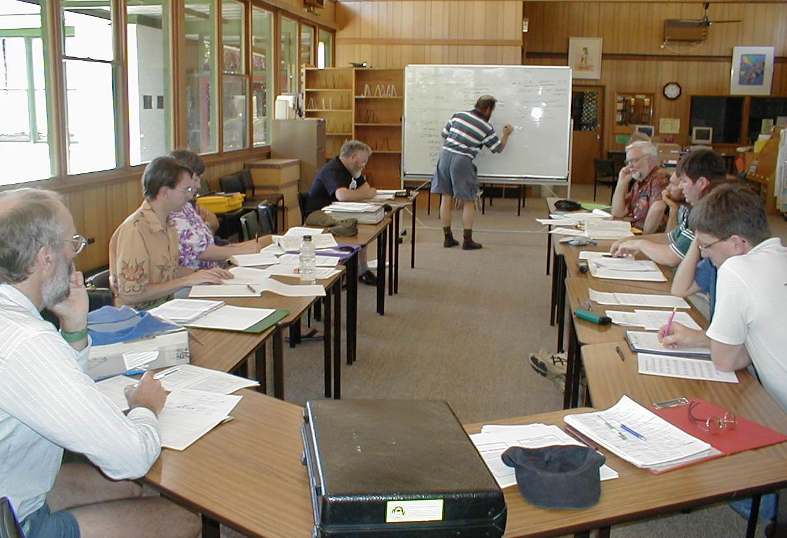
Karst Index Database discussion Group Arthur Clarke

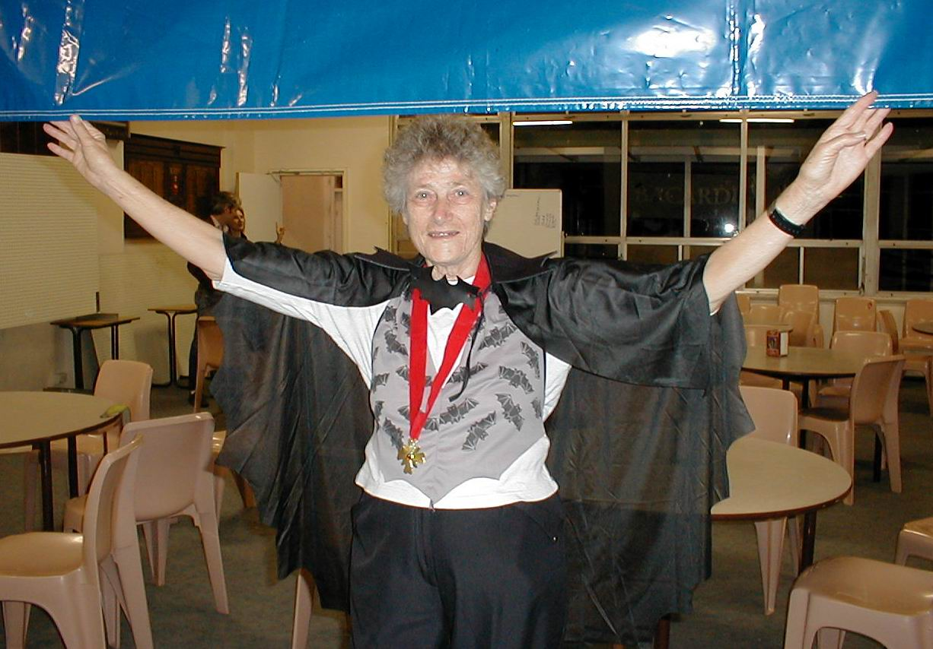
Joan Crabb at the Bat Party Arthur Clarke

Sharing information on Speleothems & Cave Minerals:
A Workshop
Jill Rowling¹

Abstract:
Since the publication of the second edition of ``Cave Minerals of the World'' by Hill and Forti (1997), there are some matters still outstanding in the field of cave mineralogy, such as a database of cave mineral samples which would be readable by the public; records of publications on cave minerals since 1997; records of type localities of speleothem and mineral types and subtypes; naming conventions for new speleothem types and subtypes.
It was proposed that something be set up to cover these matters. The workshop discussed the potential benefits (or otherwise) of such a public database, the types of users, and some of the field definitions.
It was envisaged that the work would follow many of the ideas initiated by the IUS (International Union of Speleology) Informatics Commission. It would use the classification scheme for speleothems which are defined in Hill and Forti. Field definitions would follow IUS guidelines. The idea was to help prevent duplication of work on scarce resources, as well as improve the sharing of information where possible.
This paper then goes on to suggest some of the database tables for a cave minerals Sample database.

Introduction
At the International Union of Speleology congress in 1997, the Cave Mineralogy Commission was formed. One of the achievements of the Commission has been to set up a physical location (in Europe) for the storage of representative mineral and speleothem samples. Additionally, a library is being set up to include all the references and publications on cave minerals. However what does not appear to have been set up yet is of an informatic nature (catalogues of information and databases).

The following matters appear to be still outstanding in the informatics side of cave mineralogy:
- A database of cave mineral and speleothem samples, showing who holds the sample and where the sample was taken from, together with a description of the sample. Parts of this database would need to be accessible to the public.
- Records of publications on speleothems and cave minerals since 1997. Records up to 1997 are catalogued in ``Cave Minerals of the World''. Records since then are published in various locations, some not easily searchable.
- Records of type localities of speleothem and cave mineral types and subtypes. Some of this information is in Hill and Forti, but there is some difficulty keeping this record up to date.
- Naming conventions for new speleothem types and subtypes.
- A database of new speleothem types and subtypes accessible to cave researchers, managers, etc.
It is proposed that a method of cataloging these things be set up.
The aim of the ASF workshop was to gauge feelings amongst the speleological community as to the potential benefits (or otherwise) of such a public database, the types of users, and some of the field definitions.
It was envisaged that the work would follow many of the ideas initiated by the IUS Informatics Commission. It would use the classification scheme for speleothems which Hill and Forti use as much as possible. Field definitions would follow IUS guidelines.
The idea was to help prevent duplication of work on scarce resources, as well as improve the sharing of information where possible.
On a conservation note, it is important to consider who would be reading the information, if it was available to the public. One has to balance out the need to preserve the caves and their contents, compared with the need to share information. For example, if a particular cave was the type location for a new speleothem or cave mineral, it may be decided to not make the cave ID public. Then again, if the cave was a well-known and protected tourist cave, it may be beneficial to publicise the information.
As part of my work on cave aragonites of NSW, I will need to prepare a samples database anyway. Initially, I envisaged something which would be paper based, then later web based. Partly because of the work involving the ASF Karst Index database (see http://www.caves.org.au/kid), and partly because of the availability of relatively low cost computer hardware and software, it will be easier to set up parts of the database on my PC first, then port it to the Web after the field definitions have settled down a bit (ie after consultation).
The results of this workshop were to be forwarded to members of the IUS Mineralogy and Informatics Commissions (mostly via email).

Existing relevant IUS field definitions
There are some field definitions already set up for cave informatics, such as
- The (global) cave serial numbering system
- Rock type (IUS entity 7 - Rock Type)
- References to items in the Articles database (IUS table ``atenlist'', entity AR: Article)
- Specimen (This would be IUS entity SM which has not yet been defined)
The full definitions can be seen on the IUS website at
http://rubens.its.unimelb.edu.au/ pgm/uis/index.html
For example, the IUS table ``atencode'' lists Rock Type in section 7 as per Table 1.
These can be used or referred-to in the minerals database, using the same numbers. Rather than re-keying the data, it would be preferable that in the on-line version, this information could be obtained by querying the relevant on-line Karst Index database, if it exists for that country. Presently the only Karst Index database which can be queried in this manner is the ASF's one.
There are some other problems in that although the IUS Articles database is defined, I am not aware of any implementations of it. The latest published IUS speleological abstracts are in a database, but it is not publicly accessible (ie not Web-based) and it uses different field definitions. Hopefully they will become merged.

Table 1: IUS 1998 Field Definitions for 7: Rock Type (P. Matthews)
code | meaning
02 | limestone
04 | dune limestone
06 | dolomite
08 | marble
10 | basalt
12 | dolerite
14 | granite
16 | gypsum
18 | ice
20 | lava
22 | mudstone
24 | quartzite
26 | sandstone
28 | soil
30 | tuff

New field definitions for speleothems, cave minerals and samples
The problem with the existing IUS entity, ``SM: Specimen'', is that it is not yet defined. Possibly it was intended to be used with biological specimens, possibly it was for mineral samples, possibly any specimens. The type of information collected is different in each case (biological vs mineral); possibly so different that some would suggest they should be specified in different entity definitions.
I will attempt however to keep them together: see Table 2.
Table 2: Proposed Field Definitions for Entity SM: Specimen
Entity: | SM Specimen
Field | Description
01 | Biological Specimen
02 | Geological Specimen
03 | Hydrological Specimen
04 | Meteorological Specimen
05 | ...Other Specimen (yet to be defined)

The table can be continued to accommodate additional fields.
This paper is concerned with Geological Specimens, which includes speleothems. Other people may care to tackle the definitions for their field of endeavour.
In the field of Geological Specimens, we may need to prepare Table Definitions for the following items:
Unique identifiers
are required for each sample. Note that one sample can be subdivided (broken, cleaved, sectioned, etc) into multiple sub-samples. The method I am using at present is to use the Cave Tag number, followed by a sequence (discussed later). For purposes of database field definitions, you actually need two numbers. One number is simply a unique sequence number, and the other is what is written on the sample bag or container.
Define what the sample is
using Hill & Forti definitions (or new ones where H & F is inadequate) The sample could be a speleothem, bedrock, mineral, etc (discussed later).
Naming conventions for speleothem types and subtypes
If the sample is a speleothem, it should be named (after Hill & Forti 1997). This could be a list, if the sample contains more than one speleothem. Therefore a table of speleothem types, subtypes and varieties is required. This opens a ``can of worms'' - see my article on classifying helictites (Rowling 2001)
Naming conventions for cave minerals
If the sample is a mineral, it should be named (after Hill & Forti 1997 and after Dana). This could be a list, if the sample contains many minerals. Therefore a table of minerals is required.
Crystal classification
If appropriate, crystal classification (Russian system) may be needed. Therefore a table of crystal classifications is required.
Who holds samples
For sub-divided samples, this definition may be applied to the sub-sample. There are two ways of doing this. One way is to simply have a text field, but the better way would be to have a table of people who hold samples.
Present location of samples
There could be a table of locations where samples are held.
Sample numbering scheme
Each scientist has their own way of numbering things. Perhaps we could define a scheme which works for everyone.
Tests
What tests have been performed on the sample. A table of tests could be devised, although that may be rather large. In this case, possibly there could be a table of the more common tests, with ``other'' being described as a text field.
Location
Where the sample was taken from, eg the surface, underground, twilight zone, underwater, buried in sediment, and so on as well as some description about the sample location and the cave (or nearest cave). This could be done as a series of tables together with a link to the cave ID in the Caves Database.
References
Publications on the sample (preferably cross reference as per IUS Article definitions)

Interested Parties
The following types of people may be interested in this work:
- Members of the IUS Mineralogy Commission;
- Members of the IUS Informatics Commission, so that the material is compatible with other IUS informatics;
- Cave scientists throughout the world;
- Interested cavers;
- Cave managers;
- Students and academics.

Case Study: Designing a Geological Specimen Database for the Cave Aragonites Project
In my project, ``Cave Aragonites of NSW'', I need to keep track of rock samples from various surface and underground sites. Some samples have been cut for thin sections; some are intact and others are powders. Conservation note: For this particular project, most of the Aragonite samples are pretty tiny. Further details are in Rowling (2000).
To keep samples in order, I mark the sample bags and containers with a marker pen as follows:
T/N or T/N/M
This forms a field sample ID where:
T Cave tag number (eg J105) of cave (underground) or nearest cave (surface)
N Sample number (eg 5)
M Sub-sample number (eg 3).

So the complete field sample ID could be J105/5 or W52/1/2
The idea is to be able to mark the sample bags in the field under less than ideal conditions (eg poor light, poor weather). In my field notebook, I record more details about the sample such as:
- Field sample ID as per the sample bag
- Brief description of the sample
- Description of the sample point (eg survey station number, dip and strike of beds)
- Any other pertinent information such as ``associated with old bat guano''.
Back home, I can then fill in more details about the sample as I look at it more closely under the microscope or perform some tests on it. If the sample is to be sectioned or broken up, sub-sample numbers are given to each of the pieces. For example, if sample J58/7 is to be thin sectioned, new sub-samples would be called J58/7/1, J58/7/2, J58/7/3 and so on.
Eventually all the samples will be catalogued and referenced using a small database which I will set up on my PC.
These are my proposed fields:
- Unique identifier consisting of 6 parts:
  - Sequence number: Similar to the use of ``AUASF'' numbers as used by the Karst Index, however in this case there may be several samples per cave so there could potentially be a large number of sequence numbers. Each cave scientist may need to generate their own set of sequence numbers. This is because, unlike cave surveying, which is often done by several people in a club, cave mineral sampling is more often done by individuals as part of their university study. The sequence number would be something like:
Country Code (eg AU)
Researcher code (eg JR)
Number which is assigned by the database program (eg 00005) which is unique for each of the researcher's samples. Are 5 digits sufficient? That is, 99999 samples per researcher?
  - Cave Area Code
eg 2J (for NSW, Jenolan Caves). This uses the same codes as the Karst Index Database.
  - Cave Tag Number
eg 105
For surface samples, use the closest cave tag (or the most relevant).
  - Separator /. Separators are not part of the database but they are used out in the field to label sample bags and other things. The separator would appear in listings though.
  - Sample number
eg 8
Sample numbers go 1 .. n for each sampling site (ie cave).
This information also goes on the sample bag.
  - Sub Sample Number
If the sample is derived from another, eg a thin section or a broken-off bit, an additional number identifies it.
eg 1
(use / as a separator again, same comments as before). The initial unbroken sample would be numbered 0, although it is unlikely that this number would actually be written on the sample bag. When a sample is broken up, the original sample no longer exists as such, and its sample bag may as well be numbered sub-sample 1.
- Map identification
An alphanumeric sequence which is on a map showing where the sample was obtained from. As several samples can come from one place, I use a different set of numbers to indicate where the sample came from.
The first part of this field is the map number which is based on the IUS definitions for Map Codes.
eg 2J105.JR1
Next comes a separator (again, not part of the database but it is part of the display)
/
Then the sample site alphanumeric (as marked on the researcher's copy of the map)
A1
One problem is where there is more than one map sheet referencing the sample, eg plan view and side view. The map ID is therefore better suited to a list of map IDs referring to the sample.
- Surface, underground or entrance
0 surface
1 underground
2 entrance area (twilight zone)
- Description of sample as per field notes. This would be a short text string (say 75 characters) copied from the field notebook, eg ``Red dolomitic? rock near survey point 2''
- Classification of sample. Other classifications could be added to this list.
1 Speleothem
2 Bedrock
3 Sediment
4 Speleogen
5 Organic deposit
6 Other deposit

- Type. Tables are required for each of the sample classifications, eg:
  - If Speleothem, type as per Hill & Forti (eg 3 might be ``Helictite'')
  - If Bedrock, type as per IUS Field Definitions for 7: Rock Type.
  - If Sediment, type (this requires a new table).
  - The same goes for the other classifications. An ``unknown'' type will be required.
- Sub-type. Tables of sub-types are required.
  - If speleothem, sub-type as per Hill & Forti (eg 1 = vermiform). This would reference a table of appropriate sub-types. Varieties will also need to be covered.
  - If bedrock, sub-type (eg crinoidal)
  - If sediment, sub-type, and so on.
- Orientation (to magnetic north; can be corrected using date) Possibly we may wish to record the type of orientation (eg magnetic) and the date whe it was measured.
  - dip
  - strike
- List of minerals (this is added after sample is analysed). Use the list in Hill & Forti, using a number to represent the mineral eg 1 = ankerite etc.
- Date of sample using an internationally recognised date format. Local environment settings can be used to display the date in a way which is appropriate.
- Analysis X-ref
This is a cross reference to the actual analyses of the material. Usually this is a publication or a report.
eg ``Morphology, Crystallography and Origin of Needle-fibre Calcite in Quaternary Pedogenic Calcretes of South Australia'' by Phillips, S. E. and Self, P. G., Aust. J. Soil Res., vol 25 no 1 1987, pages 429-444.
Alternatively, it could use its short reference and put the longer form of the reference in another database. I believe this was proposed some decades back for the Karst Index but never implemented.
- Analysis done
0 Not formally analysed
1 Optically analysed; see X-ref for more information
2 Other analysis; see X-ref for more information
Possibly this could be extended to list all types of analyses done on the material.
The next step for me will be to create some of the tables described above, and create a small database of my samples. The software tools for this will be MySQL (database) with a Web front end, all running on Linux. The back end software may be a mixture of PERL, HTML, and possibly PHP, all running with the Apache web server. The total cost of the software is nothing but my time. If and when I get it going it will be made available under an open source software license.
One thing that will no doubt be considered is the incorporation of this sort of information into a GIS so that spatial information can be related to samples.
I am not a GIS expert, however the short answer from those who are is ``yes - it can be done''. It is easier, apparently, to link a ``normal'' relational database (RDB) of information to a GIS than it is to link a running GIS to another database. The problem is that everything in a GIS is accessed spatially, whereas I am trying to record both spatial information (eg sample location) as well as non-spatial information (eg classification of mineral and analytical information).
There is a big push in information technology to web-enable applications. Rather than having a single large application to do everything, several applications work together to get the information to the person who needs it. Thus a web-enabled GIS could query a web-enabled RDB to give the right information.
Choice of GIS would be up to the user, however be aware that they are generally not cheap, typically several $1000.00 per seat. There is also a free GIS called ``GRASS'' which is used by parts of the US Military to depict spatial information. I will leave that as an exercise for the reader to investigate.

Discussion: Analysis Database
After samples are obtained, they are analysed. To keep track of the analyses, one can either try to remember all the work done on the samples (referring to one's lab notebook) or one can keep the information in electronic format as well so that other people can view the work later.
I'm not sure how useful it would be, compared to the Samples Database, however these are my proposed fields:
- Unique sample identifier (from the Specimen Database)
- Analysis number (alphanumeric) eg a2
There can be several analyses done on one specimen.
- Analysis performed by (create a table of people who do analyses)
- Date of analysis
- Analysis Method
1 Optical (non-polarised)
2 Optical (polarised)
3 Optical (Crossed polars)
4 XRD (X-ray diffraction)
5 EDX
6 SEM (scanning electron microscope)
7 Other (need to add more methods)
- Description of analysis. This is a short text description of what was done, eg 75 characters. A more detailed description is in the researcher's report.
- Xref to sample database (this is the sample bag ID) eg J105/2
- Other information (eg pictures, graphs, photos etc) - not defined yet
- Brief results of analysis. This is a short text description, eg 75 characters. A more detailed description is in the researcher's report.

Example: J105 samples

Field notes entry
J105 Contact Cave
Three samples from sample site marked A2.
Sample | Site | Description | Surf or UG
J105/1 | A2mid | Dolomite? | Surface
J105/2 | A2top | Limestone | Surface
J105/3 | A2bot | Limestone | Surface

data values
This could be stored in the samples database as:
AUJR00001, 2J, 105, 1, 0, 2J105.JR1, A2mid, 2, interbedded with crinoidal limestone, 2, 06, , 35, E, 210, , 20000408, , 1
AUJR00002, 2J, 105, 2, 0, 2J105.JR1, A2top, 2, crinoidal, 2, 02, , 35, E, 210, , 20000408, , 1
AUJR00003, 2J, 105, 3, 0, 2J105.JR1, A2bot, 2, crinoidal, 2, 02, , 35, E, 210, , 20000408, , 1

References
Hill, C.A., and Forti, P. (1997)
``Cave Minerals of the World.'' National Speleological Society, Huntsville. 2nd Ed.
Rowling, Jill. (2000)
``Cave Aragonites of NSW - MSc Project Report'' (in press)
Rowling, Jill. (2001)
``Cataloguing Helictites and Other Capillary-Controlled Speleothems.'' Australian Speleological Federation (in press).

Footnotes
... Rowling¹
Contact details for Jill Rowling:
work phone: 9697-4484 at Aristocrat Technologies, email at work: rowling@ali.com.au
email at home: jillr@speleonics.com.au
home phone: 9481-0949
Address for correspondance: 2 Derribong Place, Thornleigh NSW 2120.

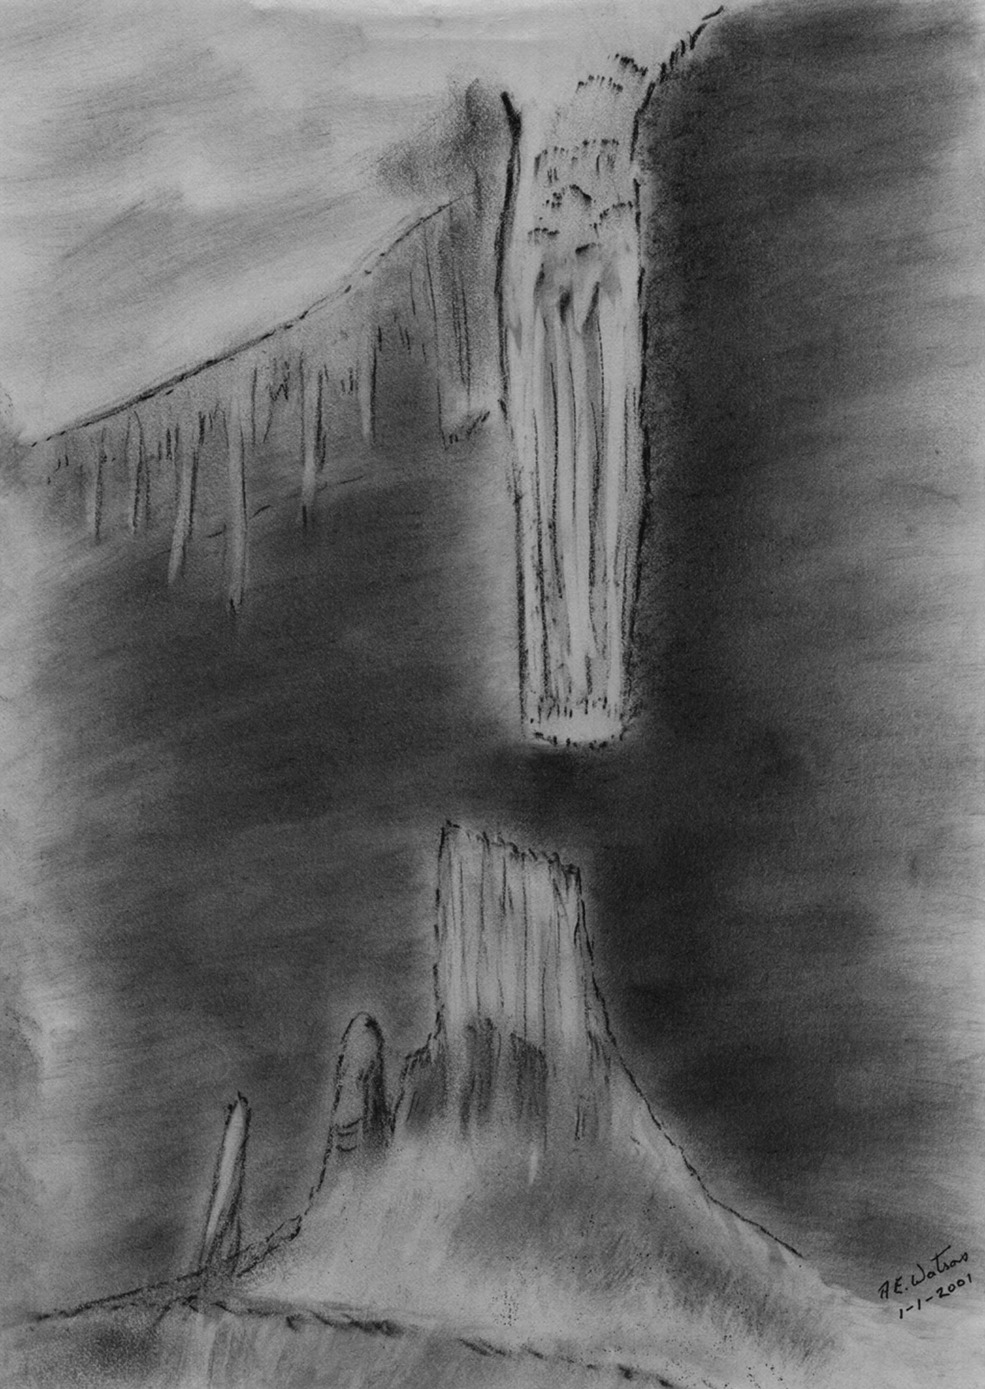
Broken Column - Tony Watson - Created at SpeleoArt
Workshop, Jenolan

Tour Description: Orient Cave Mineralogical / Speleothem Tour
Jill Rowling

More helictites and things with capillary controlled growth.
See large calcite blades on the sides of large stalagmites in Commonwealth Chamber.
Think about the domed roof: Does it have a hydrothermal origin?
A little bit of Lechuguilla only at Jenolan.
Places you don't expect aragonite.
Acid holes and drip cones.
Recrystallised calcite speleothems and a large heligmite?
Rods, wings, hands and other bizarre shapes. Medusa's heads.

Tour Description: Mineralogical tour of Chifley Cave, Jenolan
Jill Rowling.

Far from a tour of "dead and desiccated" speleothems as some person inelegantly described it, the Chifley Cave offers an interesting and rather different selection of moonmilk-coated speleothems compared with other Jenolan Caves tours. Look at the dark coralloids where air moves between Imperial and Chifley Caves. Niches show cauliflower-like efflorescences. A small deposit of "potatoes" indicates where acids from an ancient bat guano pile have reacted
with the bedrock producing a different kind of speleothem that has some of the characteristics of soils. Moonmilk-coated speleothems are mostly actively depositing. This is the cave where Iain McCulloch's "Fluffy Stuffite" is still being deposited. See the helictite complexity of Trickett's Mystery. Wonder about the rather large calcite crystal deposits just before exiting to the Grand Arch.

Tour Description: Jubilee Cave Mineralogical / Speleothems Tour
Jill Rowling

Jubilee Cave is the type locality for Ribbon Helictites.
We will be seeing these, many other speleothem types and discuss some of the reasons behind smooth vs. microgour flowstone, teeth on shawls; gour pools; triangular calcite flowstone. Colonies of micro-organisms or mineral deposits? This tour involves a bit of bending in low passages.

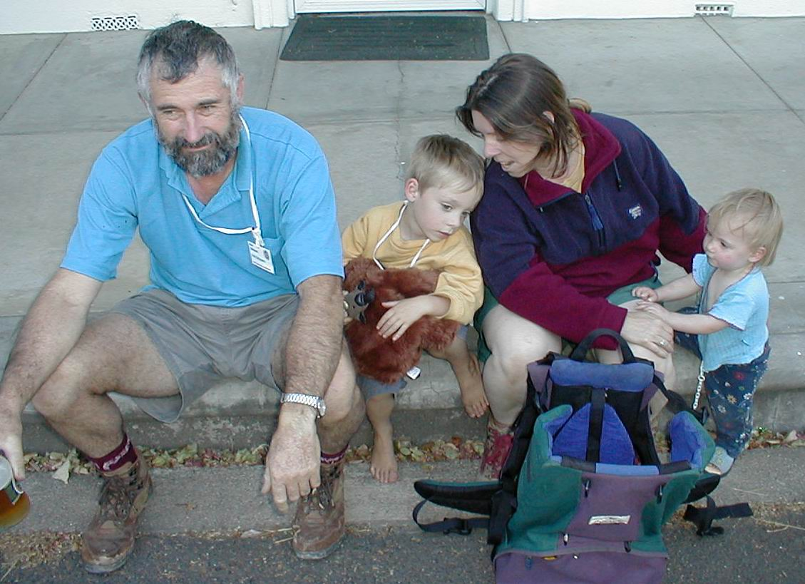

Steve Reilly and the Kraehenbuehl
clan

Arthur Clarke

THE ABERCROMBIE FOOTPRINT
A REPORT ON THE SIGHTING OF AN ANOMALY
BY
GLENN WOODLEY

Within the Arch at Abercrombie Caves lies one of Australia's most intriguing and little seen speleological mysteries.

A floor formation there perfectly resembles a giant footprint. Formations worldwide are named after things that their discoverers feel they resemble. However in this case it is more than a passing similarity, rather an exact representation of a footprint , but on a gigantic scale, well over 2 metres long !

The formation lies towards the entrance side of the old bandstand. The defining lines of the image are raised slightly above the surrounding cave floor.

Apart from its striking realism, a further mystery of this formation is its apparent ability to simply disappear . I came across this oddity several years ago, at which time I did several sketches on site, as I found it most fascinating . After initial research I found that this floor apparition had been mentioned in reports from the earliest days of Abercrombie's opening to the general public.

However since then, no other reported sightings have been recorded. Recently I went back to Abercrombie, to photograph the formation, but to no avail . I could not find a hint of it's existence, as though the whole idea was a fantasy. Yet I had seen it and recorded it with great care on my previous visit.

Perhaps mobile silt, a change in the atmospheric visuals , or just fickle fate at work. The mystery continues.

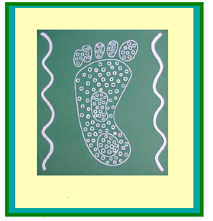

An Escape from Cave Politicians

By Paul Nelson
A visiting spelunker from California

A day trip to Borenore Caves was scheduled for ASF conference attendees not interested in cave politics, i.e. the ASF meeting held on 2 January 2001. Borenore Caves is located near Orange, NSW and is managed by the Jenolan Caves Trust. The property consists of several caves and an old limestone quarry. There is a small parking lot and picnic area, but no camping facilities, and you must bring water. We were joined by Mia Thurgate, Karst Resource Manager, who gave us some history of the site, and how it was transferred to the Jenolan Trust in 1997. She mentioned the difficulty of managing the property as there is no on-site staff and limited funds.

Mia led the group on an approximately 3 km walk to Tunnel Cave (BN-25).. A Bent Wing Bat colony resides in the cave, and it is closed during months of bat hibernation. The cave is formed a small stream cutting about 250 meters through the hillside, and exits at the other end. Even during the middle of Summer, a small stream was flowing, and there was a pond of water in the cave. The still water reflected the ceiling perfectly causing Brett Wakeman to step into the water by mistake. Brett’s mistake was my opportunity to take some pictures. The cave exits on the other side of the hill, and an easy through trip is possible. Nearby is also Verandah Cave, which I did not visit because I was unable to locate it. No doubt it is under heaps of blackberry bushes and guarded by tiger snakes. The short walk has some interesting scenery with the limestone karst visible. I was a little disappointed that I wasn’t able to see any kangaroos. (Roos are still strange animals to me, and at home I can’t see them in the wild. However, California does have the kangaroo rat, very small, endangered, and hard to find.)

After lunch, the group went to Arch Cave, which has been formed by Boree Creek undercutting the cliff through the small ravine. No lights are required, and during our visit the water level was low. When a still pool forms, nice reflections can be seen showing nice scalloping of the ceiling. There are some nice spots to take some pictures, and enjoy a cool spot away from the hot afternoon sun. I used the opportunity to further practice my cave photography skills.

The group board the bus and returned to the ASF conference for the Caver’s dinner and socializing.

In summary, Borenore Caves is a nice diversion if you’re in the Orange area, and you have friends or family that have never been into a cave before. The access is easy, no gate keys are required, and a newbie to caving will have fun. Just be sure to bring water.

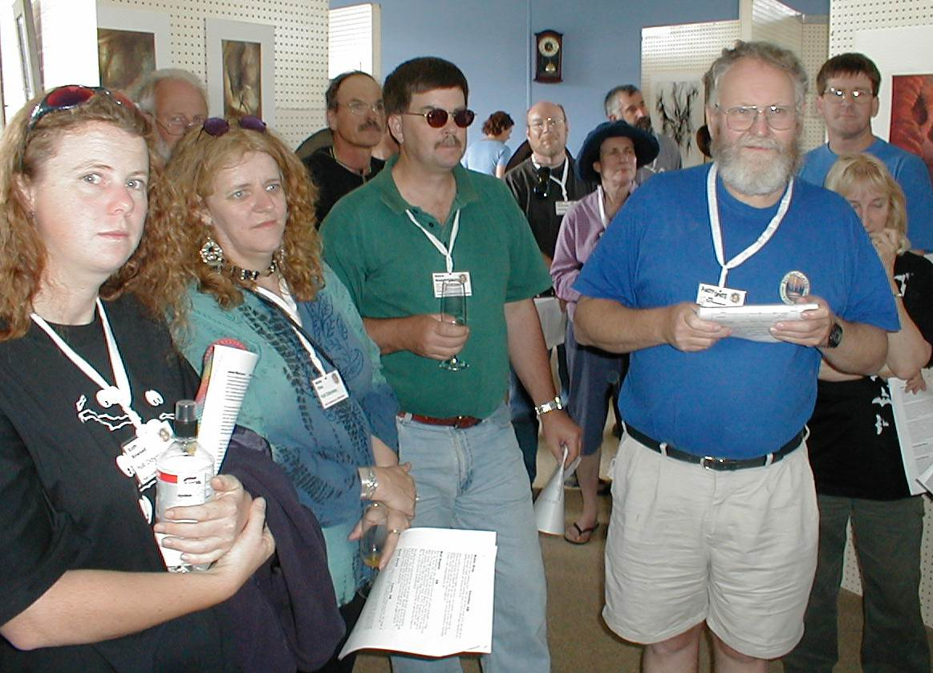 Arthur Clarke

KathRowsell, Marie Choi, Bruce Waddington, Andy Spate, Ian Collette, June MacLucas and others at the Art Show Opening.

SPELEO ART
DOWN UNDER

Australian Speleological Federation
23rd Biennial Conference - December 28th
2000 to January 3rd 2001

LIST OF ART WORK OF ISSA & SPELEO-ART MEMBERS

No Title Medium Price
Aust
Valda Gillies, NSW

From Darkness to light, apparitions in
The night W/Colour $2,650

June MacLucas - Sth AUSTRALIA
2 “Koomooloobooka Cave” Charcoal $280
3 “Tusk Cave” Nullarbor Charcoal $280
4 “Sentinel Cave” Nullarbor Pastel $380
5 “The Golden Arches Cave”
Gregory National Park, NT Charcoal $280
6 “Growling Swallet”,
Tasmania Pastel $380
- “South Arch, Old Homestead
Cave” Nullarbor Pastel $380
8 Tantanoola, S.A. Pastel $380
9 Debbie H and John D
“Birthday Cave” Gregory National Park
Pastel $380
10 “The Golden Arches”,
Gregory National Park Pastel $380
11 “Inside Knowles Cave”
Nullarbor Charcoal $280
12 “Outside Knowles Cave”
Nullarbor Charcoal $280

Ceris Jones - UK
13 “Cave-Torso” 1998 pencil/
charcoal $260
14 23“Crawling” 1998 Pencil $210

No Title Medium Price

15 “Moving on” 1998 pencil $250
16 “Still Life” 1998 pencil $210

Bud Hogbin UK
17 “Ladder” Photographic image taken $83
18 “Cascade” Goughs Cave
(Part of theCheddar System). Acrylic
Painting $165
19 “Squeeze”, superimposed
work on top. Etching $83

Mark Lumley - UK (GONZO)

20 Surveying watercolour $297

Ceris Jones - UK
21 Untitled Print $30
22 Untitled Print $30
23 Untitled Print $30
24 Untitled Print $30
25 Untitled Print $30

Carolina Brook - USA

26 Cedar Ridge Crystals
Chattanooga, USA Computer Art
27 Monlesi Ice, Switzerland Computer Art

Steve Powell - UK
28 The Walsall Limestone Mines, UK
Graphite $140
29 The great Cavern, Dudley, UK
Mixed Media $140
30 The Caves of Sladd Lane, Wolverley
Graphite $195

Jenny Keal - Wales
31 Descending Pastel $262
32 Wet Crawl Pastel $262

Pat Lawrence - UK
33 South Arch, Abercrombie Caves Watercolour $320
34 South Arch, Abercrombie Caves Watercolour $210

No Title Medium Price

Ceris Jones - UK
35 Untitled Print $30
36 Untitled Print $30
37 Untitled Print $30
38 Untitled Print $30

Robin Gray - UK
39 Wet Pitch Print $50
40 Mark Lumley in OFD Sketch book page $37.50
41 Pitch Head Print $37.50
42 Caves in Streamway Print $25
43 Weathercote, Yorkshire Print $10
44 The Fingers in St. Cuthbert’s Print $25
45 Welsh Streamway print $20
46 Peak cavern streamway Print $30
47 The Fingers in St. Cuthbert’s Print $30
48 “Caving in the early days-
Cycle lamps & a knobbly dog chalk $125
49 “Caving in the early days”
Candles & old suits chalk $125
50 “Streamway Peak Cavern” Oil Pastel $125
51 The Fingers in St. Cuthbert’s Print $30

Lucja Radwan - Austria
52 “Round the Tunnel”, Jubilee
Cave, Jenolan, NSW Water Colour $665
53 “Gem of the West”, Imperial
Cave, Jenolan, NSW Pen $650
54 “Pool of Cerberus”, Cerberus
Cave, Jenolan, NSW. Water Colour $665
55 Pillar of Hercules, Orient Cave
Jenolan, NSW Pen $650
56 Broken Column seen through stage door.
Lucas Cave, Jenolan NSW Water Colour $665

Ellis (Ian Chandler) - UK
57 1st and 2nd Avens, Polnagree, Co. Clare, Ireland $ 90
Sculptural Piece

Frantisek Mihal - Slovakia
58 Sinter Dome Pastel $100
59 Descent Pastel $100
No Title Medium Price

60 New Cave Pastel $100
61 Near Camp Pastel $100

62 Into Chasm Pastel $100

Andrew Lawrence - Jenolan Caves, NSW.
63 South Arch, Abercrombie Graphite $180
64 South Arch, Abercrombie Graphite $240

David Bellamy - Wales
65 Wet Descent Pastel $524
66 Mainstream Passage Pastel $524

Glenn Woodley - Australia
67 Untitled
68 Maya Glyphs, Matjunic Caves
69 Maya Glyphs, Matjunic Caves
70 Arawak, Mt. River, Jamaica
71 Untitled
72 Maya Glyph, Yucatan Cave Wall
73 Colong Graffiti
74 Abercrombie Anomaly

Carolina Brook - USA
75 A Natural Relationship Gouache $200
76 The Boys Gouache $200

Cartoons kindly donated to Australian Speleological Federation by Robin Gray @ $10 each with a request that they be printed in local club magazines.

3 books “The Dudley Limestone Mines” by Steve Powell @ $10 each
5 books “The Sight of Light” by Ellis (Ian) Chandler @ $10 each

The Australian Speleological Society will receive 10% on each sale.

Australian Speleological Federation
23rd Biennial Conference, Bathurst,
New South Wales. Dec 2000/ Jan., 2001

SPELEO ART AND
INTERNATIONAL SOCIETY FOR SPELEOLOGICAL ART, LEEDS, UK

BRING TOGETHER SPELEO ARTISTS FROM AROUND THE WORLD
WITH

SPELEO ART
DOWN UNDER

The founding of ISSA

Formally instigated through Carolina Brook, of Leeds, Gt. Britain, by a desire to capture the magic of limestone formations in something other than photographs and to educate the public in general to the beauty and splendour of the world that lay beneath our feet.

Carolina with a group of like minded artists/cavers met for their first workshop at the Caver’s Fair, Yorkshire 1994 when the fraternity of ISSA - International Society for Speleological Arts was conceived. Four of those founding members works are shown in this exhibition, Carolina Brook, Robin Gray, Mark Lumley and Ceris Jones.

The founding of Speleo Art

Also founded by Carolina Brook at Leeds, England as an organisation for artists and interested people to promote and recognise speleo art as a serious art form in itself. “You get a chance to see the corners ignored in the intensity of exploration and science”. (Carolina Brooks, ISSA Newsletter Vol 1 1995 p 4.) Speleo Art and Carolina have moved to Harrison USA where cave art is going forward to a brighter future.

SPELEO ART
DOWN UNDER

Speleo Artists are few and far between but we are growing in numbers and working towards being seen and heard around the world by exhibiting with groups like SPELEO ART and ISSA, INTERNATIONAL SOCIETY FOR SPELEOLOGICAL ART, both founded in England in the last few years.

In the 19th Century art cave fitted into the art ‘scheme of things’, it was sublime, picturesque, and grand. It had a power that matched the new age of steam driven machinery and the grandness of discoveries of the new far away lands. It was fashionable to portray huge refinery furnaces, awesome seascapes or sublime landscapes with huge gaping caves with great holes in the ground, it fitted the critique of fashion.

There are many illustrations from this period with black and white superb engravings of caves from the ‘new world’ but many of these images can only be found in dusty old books in libraries without any mention of the artist. In all but a few of the very famous, they are from unknown hands. Such is the fame of illustrators and the unknown artist.

Through the invention of photography last century, these illustrations usually carried out for scientific purposes, has all but ceased and unfortunately the 20th Century has remained virtually silent in this field of art.

But the creative world always swings back on itself in a bid to create something new and ‘cave art’ is new in the 21st Century. With this work offered here from a few artists, speleo art can live again as it has never been seen before. Speleo Art and ISSA have gathered these few artist represented here as well as others together from around the world and given strength to their numbers and their purpose. By exhibiting speleo art whenever possible, be it at a Speleo Conference, or exhibiting in an art gallery situation, it offers a chance to show the public the wonders that can be found far beneath our feet. Artists have the ability to record what others miss, “you get a chance to see the corners ignored in the intensity of exploration and science”, Carolina Brooks, ISSA Newsletter Vol l 1995 p 4. This then becomes a chance to educate the public that we must preserve our caves for the benefit of all of us now, as well as for the future generations.

David Bellamy - Wales
David Bellamy was born and brought up in Pembrokeshire. He mainly specialises in painting mountains and wild coastal scenes, and is particularly fascinated by the moods of nature in the wild places. He is also inspired by the dynamic interaction of caver and caves, and the dramatic lighting and atmosphere effects of these underground images. His paintings have reached private collections in many parts of the world. A full time artist and author, he has written 8 books illustrated by his paintings, Wilderness Artist, his sixth book picked up an award for excellence from the Outdoor Writer’s Guild and Watercolour Landscape Course became an art best seller. Four films on watercolour painting by David have been produced by APV Films of Chipping Norton, He also runs watercolour courses in Britain and overseas, and demonstrates to art societies.

David travels widely in search of subjects: from the prairies of North America to the deserts of Morocco, from the high Alps in the African big game parks. Often camping wild, he is then on the spot to catch the lighting at the best time of day. He takes great efforts to reach the right position to sketch, whether halfway down a cliff on the end of a rope, working from a bobbing canoe, or trying to capture the portrait of a caver in some underground streamway. Attempting to get that elusive sketch has led him into all sorts of problems, including falling over a crocodile in Kenya. He has recently returned from Tanzania where he had great fun teaching Maasai warriors how to sketch. Through his painting and writing he endeavours to bring about a greater awareness of the threats to the environment, and he is particularly active in conserving the wild areas. He is a patron of the Marine Conservation Society’s Seas for Life Appeal, He is also on radio and television in numerous programmes both painting and conservation roles, including a television series “Painting Wild Wales” with his wife Jenny Keal, in which he goes canyoning and caving in search of subjects, amongst other wild escapades. He is a member of the International Society for Speleological Art.

Carolina (Brook) Shrewsbury - Harrison, USA
Born in 1956 in the UK. Went through art college intending to become a fashion designer but got caught up with speleology. Became concerned with conservation issues and public awareness of caves. ISSA was formed, then SpeleoArt to support and promote recognition of speleo art as an art form to bring about a greater awareness of the preservation of caves for the future.
Carolina has moved to the US and is at this moment on her honeymoon in Hawaii. To see and know more, artist or punter, please contact speleoart@bigfoot.com

Ellis (Ian Chandler) - UK
MA.MCIOB.FIMBM Prof. Emeritus of Building Technology
Ellis has been a caver for over 30 years and his work is based directly on his own
caving experience. Using the 3rd dimensional form of sculpture, he often works from a specific trip taking in the effects of the environment, texture, and the dampness in the caves and uses it as a medium which he incorporated into the flow of his art work. Contact e.mail bellrock@msn.com

Valda Gillies - NSW, Australia
Valda is based in the Blue Mountains and draws her inspiration from nature in her many manifestations. Valda’s paintings explore our relationship with the natural environs. Valda has extensive experience in things speleological.

Robin Gray - Cheddar, UK
Robin Gray has been exhibiting since 1968 and has had in excess of 30 one-man shows while enjoying a highly successful teaching career as well as achieving a reputation as a leading pyrotechnician and international caver.

Gray worked at developing a highly meticulous and academic realism based on Somerset landscapes and legends. He also built a reputation as an innovative abstract painter and colourists and cartoonist with many of his cartoons published in Australian CEGSA NEWS, SSS JOURNAL AND NARGAN.
Contact e.mail robingray@nasuwt.net

Bud Hogbin - UK
Born in Derbyshire in 1942, studied at University of London Goldsmith’s College 1961-64. From 1961-70 taught art and ceramics at various Adult Educations Centres. From 1970 taught age group, becoming Deputy Head in 1974 and in 1977 became Head Teacher of a large Infant/Nursery school. In 1975-76 gained a degree and in 1984 awarded a fellowship of the College of Preceptors. Since retiring in 1985, gained a Certificate in Art & Design, a Diploma in Fine Art and Honours Degree in Fine Art at the University of Hertfordshire.

The main sources of inspiration for my work are from the study of forms found in nature, birds, rocks, plants and patterns in landscape. Recently the focus of my work is on caves and geological structures of these internal spaces. I aim to portray the “cathedral” qualities within natural caverns and to depict the struggle of man to explore and conquer these phenomena.

Ceris Jones - Lancs, UK
Born in York 1956, studied Art & Design at various Colleges and from 1983 taught at Broughton High School, Preston, UK. A founding member of ISSA is now the Secretary of the group.

Ceris interests are mainly concerned with the body and in particular cavers, divers and cave divers where the human form undergoes an almost animal-like appearance when aids, attachments and breathing apparatus are added. “To go into the unknown holds feelings from obsession and apprehension to almost total terror, these feelings is what I try to capture”.

Jenny Keal – Wales
Jenny Keal became interested in painting in her early teens but only took it up seriously in recent years and now combines being an artist with running her own business. She has paintings in collections all over the UK and in America.

She was, at first a reluctant caver, showing no interest to take to the sport. Gradually, however, under a little pressure, she persevered and no enjoys reasonable trips under the ground,

The inspiration for her cave paintings comes from being in a hostile environment of cave systems. An element of excitement and mystery are strong features of her work reflection the inner strength and fortitude requires to cope with danger and discomfort encountered underground.

The tremendous drama of the human figure struggling and heaving impossible situation provide a challenging subject for any painter.

Add to that the primeval fear of confined spaces and bottomless pits and you have a receipt for touching the viewers emotions as no other subject can.

Jenny tries to use her own deep seated fears to tap with well of emotion in her viewer.

Andrew Lawrence - Abercrombie Caves, NSW.

Andrew Lawrence was born in Newbury, England. He studied Art and Design at Bristol Polytechnic then Audiovisual Design at Stoke-on-Trent Polytechnic in the late 1970’s.

It was while he was at college that Andrew developed an interest in caving, initially through an invitation to undertake a photographic shoot in the caves of the Forest of Dean.

He was a founding member of Newbury and district Caving Club and became an avid caver in the Mendips, Wales, the South Coast, the pot holes of Yorkshire and Derbyshire, and the river caves of Fermanagh and Sligo in Ireland.

Andrew travelled extensively in the early 1980’s, before settling in Australia in 1983. He established his own business as a freelance artist in Concorde NSW until 1986, accepting commission based work, utilising mainly oils and acrylics and exhibiting in the local Sydney area.

In 1987 Andrew accepted a position as guide At Abercrombie Caves, NSW in order to pursue a strong interest in Speleology as well as to be closer to the Australian bush. His cave photographs and graphics have been used for numerous Abercrombie Caves promotions and signage for the Arch Cave self guided tour. He has won first prize in the Heritage section of the Evans Arts Council photographic competition.

Andrew still maintains a close relationship between Caving and Art through his current position as Visitor Services Manager at Jenolan Caves, NSW.

Mark Lumley - Bath, UK
Mark has been involved with art for some time and has his own flourishing Art Design business. A caver for over 20 years Mark has been on caving expeditions to Spain, Austria, Mexico and the United States that included a trip to the famous Lechuguilla Cave system. The diver shown in his work here was painted from a small sketch carried out while diving, using plastic sketch pad and pencils on string.

June MacLucas - Adelaide, South Australia
Born in Adelaide has a Diploma of Art and a Bachelor of Fine Art. In 1989 she completed the largest charcoal drawings by one person ever to come from Australia, totalling 64 metres in length by 3.5 in height. The actual specifications of the convict built Ross Bridge, in Ross, Central Tasmania, built in 1839. The next few years were spent completing huge works taken from her own dreams by using the theories of Carl Jung and dream interpretation as well as his theory on the psychological transformation found in medieval alchemy.

With her interest still centred on the unconscious, it was a natural step to join her husband and friends by joining CEGSA, Cave Exploration Group SA. Since then her style of work has completely changed, no longer the huge “audience participation of walk into” size works but rolls of paper, boxes, easel etc., are now taken into some of Australia’s most beautiful show caves of the Blue Mountains, or some of the more remote caves of the Nullarbor. Left to get on with it, June enjoys the solitude and the challenge of drawing in caves using form and many layers of colour to portray her own emotional response.

In 1994-96 June coordinated and took part in INSIDE EARTH-CAVES BENEATH THE NULLARBOR touring exhibition to 5 leading Australian galleries in 4 different states. The exhibition included many of Australia’s leading cave photographers, Norm Poulter, Kevin Mott, Ken Boland, including Elery Hamilton Smith who officially opened 4 of the exhibitions. Since then June has exhibited solo in various galleries around Australia including an exhibition held at Abercrombie Cave NSW celebrating Australia Day 1998 when Elery launched his new book Perceptions of Australian Caves in the 19th Century: The Visual Record, and Nineteenth Century Paintings, Drawings and Engravings of Australian Caves. Pub. Through Helictite Vol.35 (1&2) price $20 contact Email elery@melb.alexia.net.au. Contact June MacLucas. junemacl@senet.com.au

Frantisek Mihal - Slovakia
Mihal has been a caver for over 20 years and in 1972 took part in the discovery
of Stratena Cave. He travels all over the country side on his bike or skis drawing wherever he can. Mihal has found that he has discovered Stratena Cave all over again, only this time in pencils and coloured chalk.

Steven Powell - UK
I am an avid cave and mine explorer and take great delight in their history and conservation. I have written cave articles and a book on the Dudley Limestone mines in England and I am currently completing further works on English Subterranea. My main enjoyment comes from recreating cave entrances and underground scene that I visit; the finished articles always give character to subjects that look dull on photographs.

“The Great Cavern” is part of a huge underground limestone mine that played

a large part in modern history in that during the year of 1839 Sir Roderick Murchison, the world famous geologist, completed his vision of the Silurian rock series and lectured to a host of thousands by candlelight and coloured fires. The balconies seen in the picture are where this lecture took place.

The lurid colours of the limestone columns are my own view of the reflections given from the coloured fires and candles.

“The Wolverley cave houses” were excavated from the 1780’s onwards, it was cheaper for folk to excavate into the soft sandstone rock and make rooms, some are completely subterranean, others have brick or stone fronts. This particular picture depicts a dwelling that was lived in until recent times circa 1948. This particular spot, known as the “Sladd” is very peaceful and romantic and would have been a most beautiful place to have lived. It is noted that the “cave people” or Troglodytes” always kept good health and lived extensive simple lives.

“The Walsall Limestone Mines” were excavated for stone to use as flux in nearby iron foundries and for lime mortar. The extensive galleries were created between 1789 to 1920. The difference beds of limestone create fantastic patterns and shapes and being part flooded reflect a beautiful mirror image. The caves here are near total collapse and I felt obliged to capture them before they are gone forever.

Lucja Radwan - Austria
Speleo artist from Austria. Member of the Austrian Artists Professional Association and a member of the St.Lucas Association of Artists (Antwerp -Vienna). Exhibiting since 1985 her work has been exhibited in Austria, Poland, Switzerland, Japan and Hungary. Essentially a water colourist the world she perceives is shown in a new and different light. She is continuously looking for hidden places, and recesses; finding the beauty that is often unnoticed by an inattentive observer.

